**Task 4. WEB UI Forms**

To create a basic WEB UI frontend for the application, you can use any UI framework of your choice. In this example, we will use React.

Step 1: Create a new React project

You can use the following command to create a new React project:



Step 2: Install the Axios library

The Axios library will be used to make HTTP requests to the backend API. You can install it using the following command:



Step 3: Create a ServerList component

This component will render a list of all servers. Create a new file called ServerList.js with the following contents:

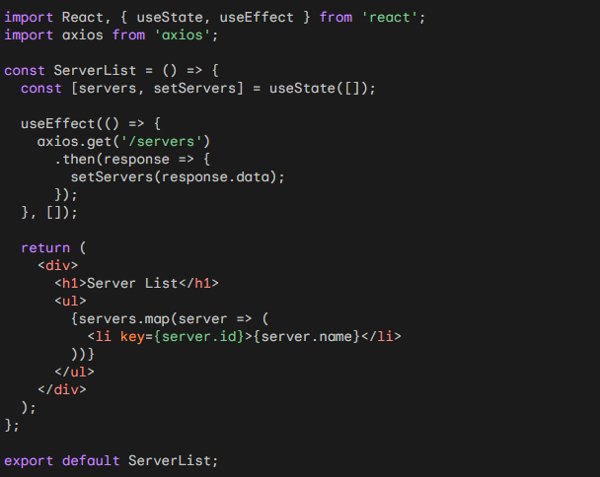

Use code with caution. Learn more

Step 4: Create a ServerForm component

This component will render a form for creating and editing servers. Create a new file called ServerForm.js with the following contents:

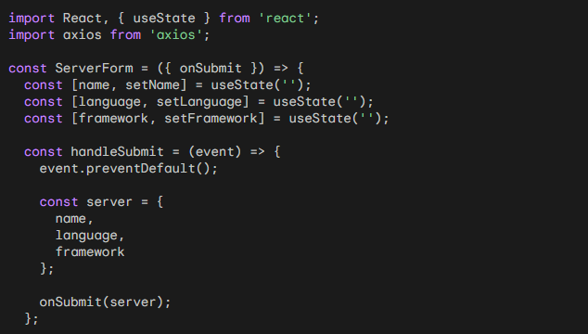

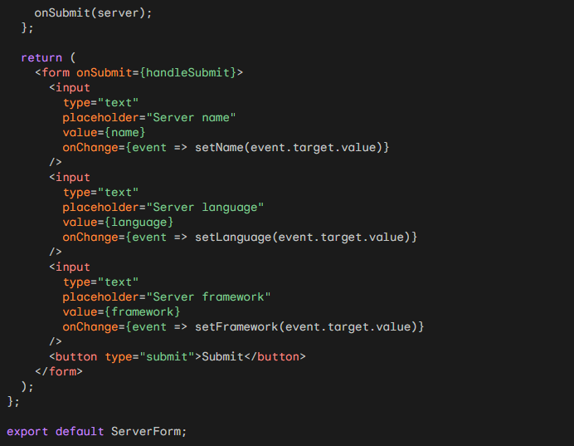

Step 5: Create an App component

This component will render the main layout of the application. Create a new file called App.js with the following contents:

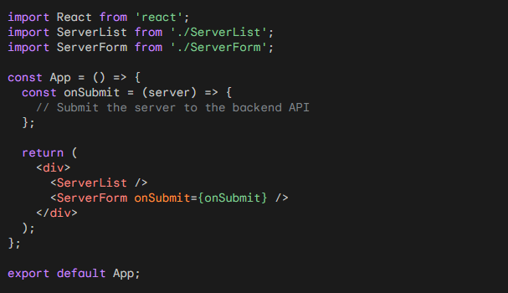

Step 6: Start the React application

You can start the React application using the following command:



This will start the development server on port 3000. You can open the application in a web browser by going to http://localhost:3000.